|  |
| --- |
| Project Proposal |
| GLOBLOCK |
| BSHCE BSc in Computing |

|  |
| --- |
| Alex Quigley - x10205691  10/6/2013 |

Table of Contents

Introduction 3

Project Information 3

Project Objectives 4

Concurrency Control 4

Physical Token 4

Repository Management 4

Background 5

The Dot Conf 5

Repositories 5

Physical Token 5

System Users 5

NFC 5

Technical Approach 6

Hardware 6

Software 6

Special Resources 7

Arduino 7

Android with NFC 7

PC 7

Server 7

Project Plan 7

Technical Details 8

Arduino 8

NFC Device 8

Management Suite 8

Website 8

Server 8

Database 8

Evaluation 9

Real world Interaction 9

Heuristic Evaluation 9

Walk through 9

Performance 9

Consultations 10

Stephan Weibelzahl 10

Hardware Implementation 10

Complexity of Functionality 10

Reflection 10

Francis Sheridan 10

Business Case and Testing 10

Reflection 10

Open Innovation Employees at Intel 10

Business Case 11

Competition with Existing Systems 11

Reflection 11

Proposed Supervisor 11

Appendix A 12

Appendix B 15

# Introduction

This document is a deliverable for a final year project as part of an Honours Degree in computing with the National College of Ireland.

The project proposal will first outline the important information, the projects objective and description of its functionality, as well as the background information on how the solution came about.

It will then discuss the technical approach used for delivering the project and any special requirement for its development and delivery. It will introduce the project plan which will be backed up by Appendix A, and the technical details of the project such as the Technologies and programming languages used.

Finally, there is a section dedicated to how the project will be evaluated. Finishing with a brief description of the consultations that occurred (referencing Appendix B) with the lecturers and industry professionals, and how I reflected and actioned these consultations.

# Project Information

|  |  |
| --- | --- |
| Project Title: | Globlock |
| Course Code: | BSHCE4 |
| Couse Title: | BSc (Hons) in Computing |
| Course Specialisation: | Network and Mobile Technologies |
| Student Name: | Alex Quigley |
| Student Number: | 10205691 |
| Date: | 06th October 2013 |

# Project Objectives

## Concurrency Control

The objective of my chosen project is to provide a means of concurrency control on a single file or group of files, with a revision history and reporting capability. This system would be developed to support a team of users who would have a business need to prevent the possibility of multiple versions of a file or files in circulation.

## Physical Token

In parallel, the file or files would be tokenised. The soft copy or digital representation of the file on the system (whether they be stored locally or remotely) would be represented by a physical token in the real world, in the form of a small durable ball.

By tokenising the file or files, it is then possible to prevent multiple user change access and multiple revisions at any given time. Only the user in physical possession of the token, having granted them access through the system prior to creating the token, would be able to make changes to the file or files.

The physical handoff of the token in itself is also something meaningful at a psychological level such as the passing a baton from one person to another.

## Repository Management

A robust management system to control each token and their associated files would support administration of user profiles and access rights/permissions, and would allow high level users (super users or admins) to assign files to tokens, review change comments and current status, as well as attach comments for users when they take possession of tokens.

# Background

## The Dot Conf

The idea came about during the ‘dot conf’ I.T. conference held at the National College of Ireland. I attended the event in 2012 and had been given a small stress ball from Grafton Media as part of the welcome pack. I was researching home automation systems and RFID for personal projects at the time and something struck a chord with me.

## Repositories

Having worked with repositories in the past I have always found them to require technical knowledge to make full use of them and found them to be out of reach of unskilled or untrained I.T. professionals. Particularly around reducing duplication, the potential benefits are quite obvious.

## Physical Token

Providing a physical abstraction of a digital file or grouping of files, would allow technical as well as non-technical professionals to take advantage of the benefits of repository management. This abstraction would be a token in the form of a small stress ball, with an embedded RFID.

The ball with embedded RFID would be placed on an RFID reader, connected to each users system. The id from the embedded RFID would be read and if the user had been granted access to the file or files, then they would be downloaded locally and now be accessible to that user.

Upon completion of any changes and removal of the ball from the reader, the file or files along with the recent changes and any comments made by the user, would be uploaded to the system.

## System Users

A repository of each revision would be maintained on the system, and all comments from the user would be visible to the next user to take possession of the ball and gain access to the file or files.

A super user would have the ability to track changes, comments and status of all revisions under their remit within the system, as well initiate new balls and add files, and any other value processes that would be expected from the system.

## NFC

The use of NFC has become increasingly popular among phone manufacturers. There is also a potential to sync a mobile android device with a laptop or pc, which would remove the need for an RFID reader attached to the system.

# Technical Approach

## Hardware

The hardware to be used will be an Arduino device with Ethernet. The device will be powered by Ethernet and an RFID reader shield will allow the id to be sent over the Ethernet to the attached pc or laptop. The Arduino device will be housed in a casing to allow the ball to rest on the device and provide basic indicator light functionality to inform user of balls that are added or removed.

I have researched this form of communication through a number of different methods and found that Arduino will provide the most suitable platform for development as it is open source and has a large following which will mean large support groups for developers.

Each ball or ‘globe’ will have an embedded RFID chip which are inexpensive, and easily replaceable.

A server will be used (local or remote) as a repository for files and also to host the database for the system.

An Android handset with NFC functionality may be used instead of the Arduino device to allow mobility of the system.

## Software

A robust and secure software system which will require some components to be installed locally will allow an admin user (super user) to create new user profiles and create ‘globes’. Each globe may contain a single file or multiple files, which will be added by the admin user. This information will be stored in a remote database, on a local network or remote network.

The super user will then place a new ball with embedded RFID (globe) onto the Arduino device (block). An API will communicate with the ‘block’ and read in the ID from the ‘globe’. This association will be stored in the database.

Once the ‘globe’ it’s state will become ‘live’ and when a user on a separate system using a separate ‘block’ places the ‘globe‘, the files associated with that globe will be downloaded to a temporary folder on the local machine.

When the ‘globe’ is removed, the files with changes intact will be uploaded to the server and the revision history stored in the database. The user will be prompted to add comments in relation to any changes made.

The server will run an Apache installation with PHP and MySQL. This will provide a landing page and the necessary email functionality for reporting. It will also allow the user account preferences to be edited using a login and also password retrieval and updates expected from a system such as this.

An android application will be installed on any android devices that wish to make use of the system. This app will allow syncing with user accounts to software on the local pc so that the handset will act as a ‘block’ in place of the Arduino.

# Special Resources

## Arduino

As the project requires hardware elements, an Arduino UNO with RFID reader shield and Ethernet shield will be required. A number of online resources will be used to develop for the Arduino platform, in the form of tutorials and forums.

## Android with NFC

Separate to this, an Android Device with NFC capability will be needed for a more mobile solution. In order to develop for these technologies I will require a particular book. Professional NFC Application Development for Android (Coskun et Al, 2013), will be used as reference material for the development of the mobile application in order to use NFC in place of an Arduino device.

## PC

A personal computer will be used to the develop the platform, test, and create documentation for the entire project.

## Server

An apache web server with PHP and MySQL will be required to provide a landing page, email functionality and Database storage.

# Project Plan

The figure below illustrates an outline of the project in the form of a Gantt chart. This project plan illustrates implementation steps and individual activities as well as key milestones and deliverables.

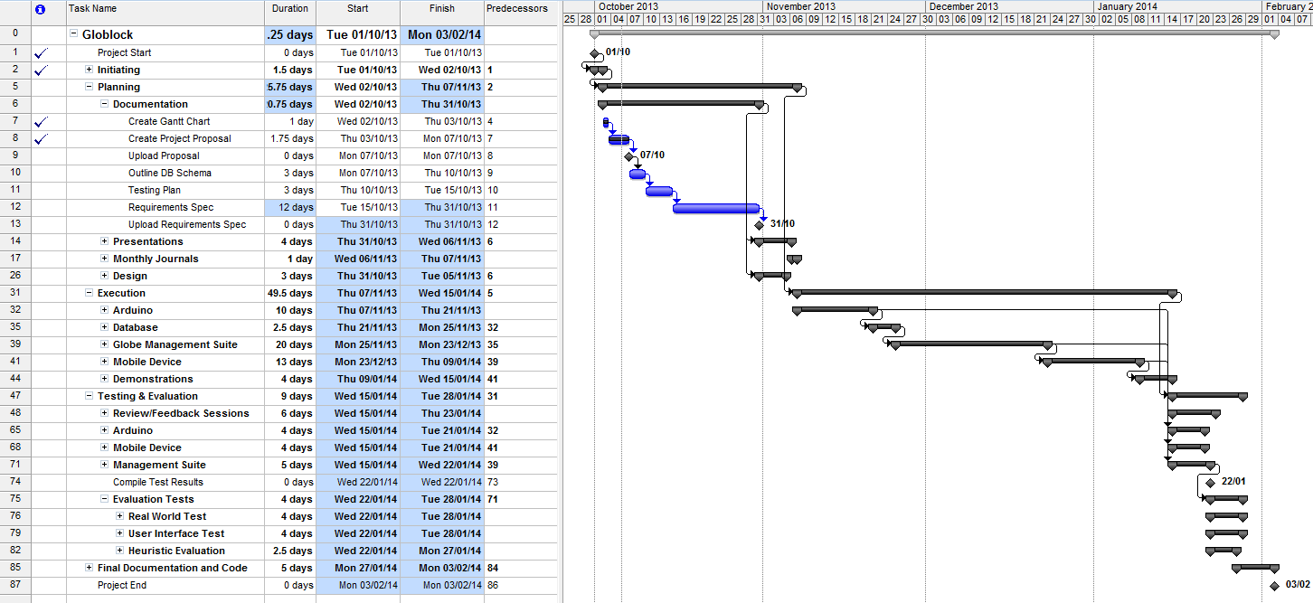

Full details of the plan are available in Appendix A.

# Technical Details

The latest versions of all the below listed technologies will be used where possible.

## Arduino

The Arduino Sketch software will be used for the development of the hardware side of the project, and the Arduino device. This is essentially an open source C/C++ based language IDE used exclusively for accessing and manipulating the functionality of Arduino devices and other makers boards.

## NFC Device

The NFC device will be developed using a combination of Java and sqlite. This will be developed in the Eclipse IDE as well as other common Android development environments.

## Management Suite

The management suite, being the most complicated of the components will be developed using Java, PHP and Windows Scripting. The development environments will be Netbeans, Eclipse, Visual Studio as well as many other IDE’s and editors.

## Website

The website will be developed using HTML5, CSS and PHP, all from within Google Web Development suite and other third party web development editors.

## Server

The server side setup will utilize Apache, MySQL and PHP.

## Database

A MySQL installation will be used for the main db and sqlite for local storage on the NFC device and for the Management Suite if Required.

# Evaluation

## Real world Interaction

A real world test will take place that allows users to interact and use the full system as they would in a normal working environment.

A common process to my current position as a document controller with Intel Ireland is that a report is generated at the end of each working day. To complete this report, each member of the document control team completes an evaluation of the day’s events and provides statistics and metrics on the number of processes and tasks completed by project during the day. This report is passed to each member of the team to complete, and is finally compiled and reported to the document control manager and filed away.

I will use this reporting process as a test case to evaluate the system. The report will be tokenized by the system and associated to a globe. The globe will be passed to each member of the team. Each member’s interaction will be closely monitored over the course of a week while they use globlock to interact with the system.

## Heuristic Evaluation

Assessing the usability of the Management Suite user interface, a comprehensive list of tasks and processes will be created and each user of the system will rank these tasks in terms of consistency, usability, responsiveness and intuitive design.

## Walk through

A walkthrough will be documented for each end to end process of the system and will identify potential issues of usability, and also to provide a basic outline of instructions for users of the system.

## Performance

The processor usage during the system evaluation will be charted and graphed to identify high processor usage during particular tasks which could cause potential system or performance issues.

# Consultations

## Stephan Weibelzahl

When I initially proposed the project solution, I reached out to Stephan via email with the attached rough outline of my concept (Appendix B). I had chosen this particular lecturer to approach as he has worked in the eLearning laboratory in the college as well as being well regarded in the areas of user experience and UX Testing.

### Hardware Implementation

Stephan was impressed that I had chosen to marry hardware and software. He pointed out that the hardware itself will not be complicated to implement. The function of RFID reader shields on Arduino is to read the ID and pass to the system this functionality will be relatively straightforward.

### Complexity of Functionality

Where there may be an issue was that the supporting software would require considerable complexity and would need to be spelt out in greater detail in order to make the project a successful one. He also suggested looking to utilize existing document management systems, to allow the finished project to be implemented or integrating into existing companies installations.

### Reflection

I looked at working alongside existing revision and document repositories however I found that there would be a requirement for tacit knowledge of these processes which could potentially.

However, I could clearly see his point that a more robust management system would add a great deal of value and appeal to the project.

## Francis Sheridan

I approached Francis with the rough outline as I did with Stephan (Appendix B). I chose Francis as I had been working with her while I was working as a Lab assistant in the college and had been assigned to her Object Oriented Programming class. I decided to ask her opinion as she is clearly very knowledgeable and competent in the areas of software development, and object oriented programming.

### Business Case and Testing

I had explained the idea and she was positive about the concept, but said that one area to give plenty of attention to would be allowing the competed system to be well tested in a real world environment and that the analysis of its success or areas for improvement, as well as the metrics gathered during this testing would be very valuable.

### Reflection

During the Evaluation stages of the project I have outlined where the system can be fully tested with its users being observed. These observations will be recorded and perhaps lead to improvements in the system and its usability and appeal.

## Open Innovation Employees at Intel

I had met to discuss my project with two colleagues at Intel who are based in the Open Innovation center.

### Business Case

Both colleagues again were interested in the idea. They both expressed concern however that the business need for such a system would need to exist for the project to be successful. For example, if the project is fully completed and functioning as expected, but people do not want to use it then it is not a successful project.

### Competition with Existing Systems

Another point raised was that although the goal of the project is to prevent more than one user accessing a file at a particular time, particularly in development environments, there are cases when users are required to access the same files and even go as far as edit them, at the same time.

### Reflection

I looked at where the system could add value to a company or a team of colleagues who would work on the same files. I have a lot of experience in office environments and have on many occasions found it difficult to keep track of files without the use of a complicated repository system.

I feel this particular project will allow a wide range of users benefit from a repository system but at the same time hide the complication by providing the abstraction of a token, in this case, a globe.

# Proposed Supervisor

A proposed supervisor has yet to be confirmed. I feel where I will find the most difficulty in completing this project will be time management and the development of the ‘Management Suite’ section of the software.

I would benefit from a lecturer who will be able to allocate a small amount of time but on a regular basis to allow some feedback on my progress. These regular sessions will allow me to segment my time and the project activities and deliver them within the allocated times.

A lecturer with previous experience in Android development and medium to large scale software systems would also be very beneficial.

_______________________________

Alex Quigley

10205691

BSHCE4

# Appendix A

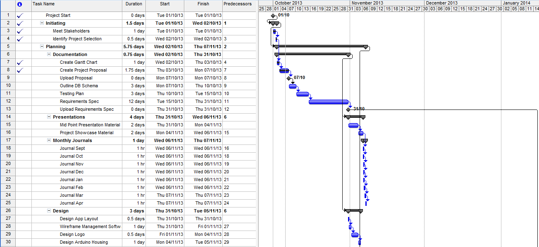

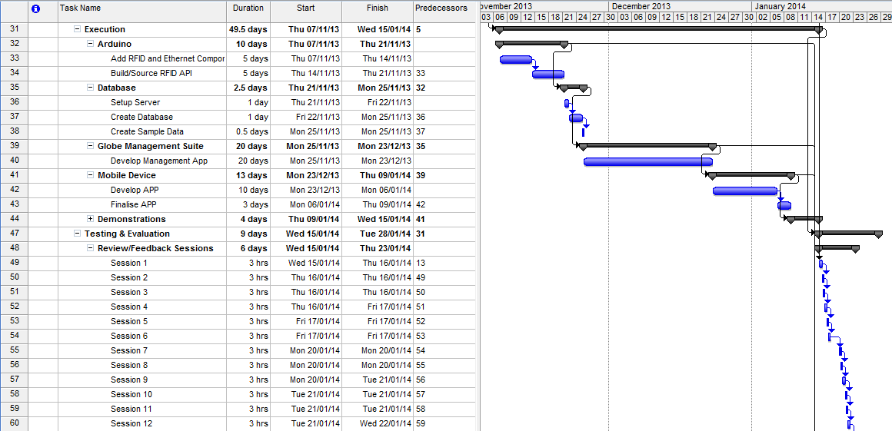

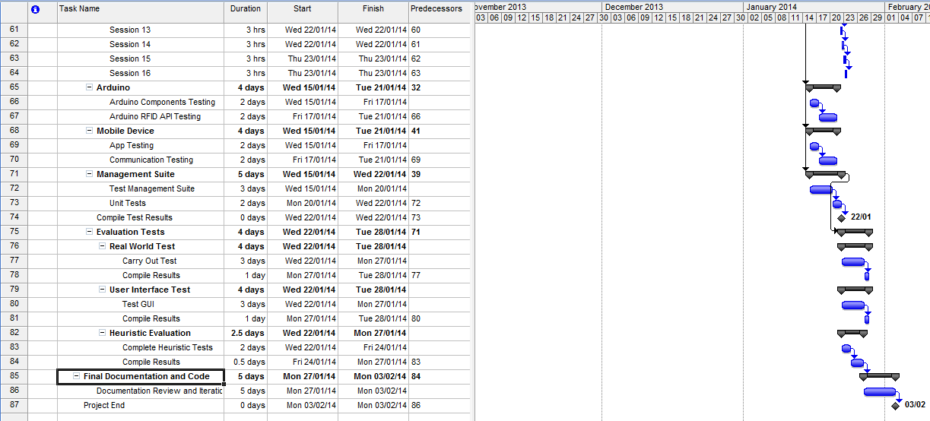

# Appendix B

Ball: RFID embedded in soft sponge ball.

Stack: Custom built housing, containing RFID reader mounted on Arduino/raspberry pi device. Device wirelessly communicates with PC and PC software.

When a ball is placed on the stack, a unique RFID is sent to the software, which in turn searches a cloud storage or Network DB for an associated file or group of files.

When the file is located it is downloaded locally and the user may begin making changes to the file or files. During this time, other users may only have view access to the file/files. When the user is ready they will save the file, which will update to the cloud or network DB and remove the ball from the stack. A note/comment is logged through the software, and the ball is now free to be passed to other colleagues for editing/changes.

A project manager or admin user, may begin the process of associating files with a ball. If a ball is lost, they may associate old files with a new ball and discard previous associations.

The aim of the entire project is to provide a physical abstraction of a digital file / files. Particularly in development environments this could be useful as a means to eradicate issues with version control where more than one developer/programmer has access to particular files.

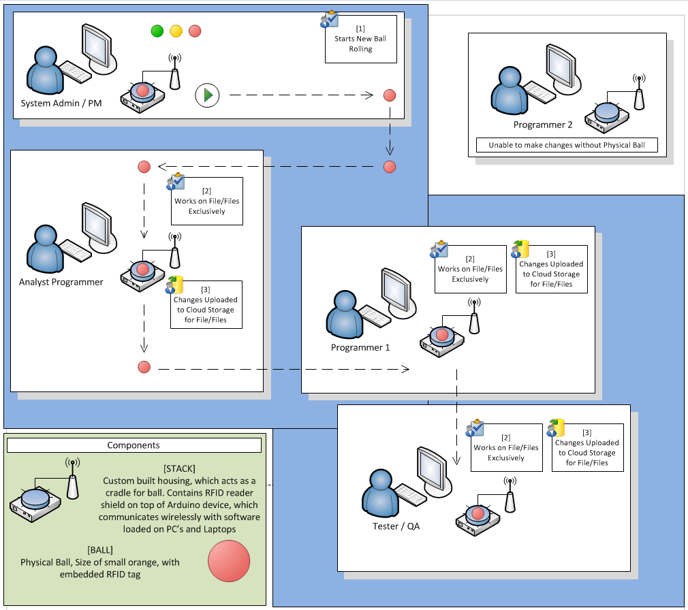

I originally though of the idea during the dot conf. I found a stress reliever ball in the goody bag from Grafton Media. I had wanted to include some form of hardware for my 4th year project. It would also be possible to create an Android version of the ‘stack’ now that Samsung have been introducing NFC in some devices. The reason why the stress ball appealed to me as a housing for the rfid is that it can be physically thrown without hurting someone.

I have done some basic research and I feel it would be achievable but at the same time provide a high level of complexity, functionality and commercialism. One concern I would have is that the RFID would be too easily damaged if the ball is squeezed, or that the rubber/sponge material, will cause RFI with the reader.

I think I would likely choose arduino over raspberry pi, due in part to its current popularity, low cost, and the wide range of additional components which may benefit the product such as sensors, led indicators, speakers etc.. It also has a smaller physical profile. I was thinking of creating a 3D model for the housing and using a 3d printer to create a prototype, I had some design ideas around this.

